Please enjoy this special savings offer as our thanks to you.
15% OFF  your next regular, sale, or clearance priced purchase from Stores, Catalog, or jcp.com | 
“JCPenney Customer Satisfaction Survey” 15% off savings coupon does not apply to Value Right, “2 or more” prices, Cosmetics & Fragrances, Cookware, Cutlery & Gadgets, Jewelry Bonus Buys, Floor Care, Furniture & Mattresses, Personal Care Appliances, Small Appliances and Electronics, Clarks, Columbia Sportswear Co., Easy Spirit, Hunter Douglas, Levi’s, Services, Salon Services & Service Contracts, or Gift Card/e-Gift Cards, prior purchases, and the following additional jcp.com/catalog merchandise purchases: JCPenney Custom Fit Clothing, Jodee Catalogs, Combo Prices, Fine China, Holiday indoor/outdoor decor, Santa suits & accessories, Housewares, Infant (Bedding/Furniture/Wheeled Goods/Accessories), Jewelry, Musical Instruments, Pet Items, Pools, Scooters, Sporting Goods, Toys, Video Games, Grand Patrician, Oreck and Teleflora. Discounts cannot be combined with any other discount coupon/certificate or applied to orders currently being processed. No Cash Value. One coupon per customer. Coupon must be surrendered at the time of purchase. Unauthorized duplications, reproductions or facsimiles of this coupon cannot be accepted. Discount is applied to all qualifying items purchased on a prorated basis; any applicable refunds will be given in prorated amount. Discount does not apply to Buy One Get One offers during selected storewide savings events. JCPenney Associate and Retired Associate purchases are excluded from this offer. Only one “JCPenney Customer Satisfaction Survey” coupon per household may be redeemed during any 30 day period.
Offer valid through 10/21/2007
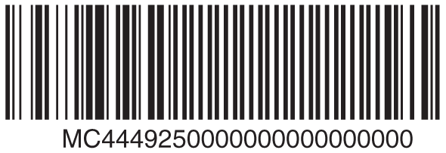
For jcp.com/Catalog orders: Shop jcp.com, check “yes” under discounts and key SEPTSURV in the promotional code box during checkout or call 1-800-222-6161 and ask for code SEPTSURV.

